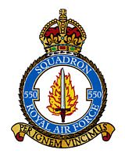
`

550 SQUADRON ASSOCIATION REUNION
Friday 12th and Saturday 13th July 2024

BOOKING FORM
Name of Member:
Accompanied By:
Home Address:

Telephone No: Email:
Special Requirements (eg wheelchair etc) :
Accommodation at the Ashbourne Hotel
Members and friends must reserve rooms directly with the hotel and pay their own accounts on departure. The Association will not be booking any individual rooms, but we would like to know the names of those who are staying.

Friday 12th July:

Saturday 13th July:

Church and Afternoon Tea & Cakes. Number of places:

Associated Events – Sunday 14th July
Tour of North Killingholme Airfield by car - led by George Turner Number of places:
This is an informal tour that George is happy to lead if there is sufficient interest

Annual Subscription
Annual Subscription for year beginning 1st July 2024 will remain at £5.50 per person. Payments by bank transfer are preferred and the association’s bank details are as follows:

Sort Code : 30 - 93 - 72 Account Number : 01206018 Please reference any payments with your name.

If you have not already made bank arrangements, you are invited to pay now by cheque

Number of members ___________ @£5.50 per head: £
Names of members being paid for

TOTAL PAYMENT : £

Cheques should be made out to “550 Squadron Association” and returned with this completed booking form NO LATER THAN FRIDAY 21st JUNE to:

Liz Broddley, 15 St Crispins Close, North Killingholme, North Lincs, DN40 3JN
Telephone: 01469 540628 Email: lbroddley@gmail.com

Meal Requirements
The menus for Friday and Saturday nights are shown below. Please indicate below your choices. Members must pay the hotel directly for all meals taken.
Please advise below if you have any special dietary requirements:

Friday 12th July 8.00pm. Relaxed, informal evening . No seating plan.

2 courses £22 per person (Starter & Main - or - Main & Dessert)
3 courses £26 per person ( Starter, Main & Dessert)

STARTERS:
 | Name | Name | Name | Name
Homemade Mushroom Soup
Breaded Ham Hock
Crispy Whitebait
Chicken Liver Parfait
MAIN COURSES:
Gammon Steak
Traditional Beer Battered Haddock
Braised Blade of Beef
Root Vegetable Pithivier
DESSERTS:
Warm Chocolate Brownie
Baileys Cheesecake
Sticky Toffee Pudding

Saturday 13th July 7.30pm. Formal Dinner with seating plan.
3 courses £32.00 per person ( Starter, Main & Dessert)

Seating Preference: Please let me know if you would like to sit with anyone in particular:

STARTERS:
 | Name | Name | Name | Name
Vegetable Soup
Mackerel Parfait
Garlic Mushrooms

MAIN COURSES:
Roast Sirloin of Beef (Cooked Pink or Well Done)
Honey Roast Ham
Loin of Cod
Roasted Butternut Squash
Thyme & Truffle Gnocchi

Treacle Sponge
Dark Chocolate Delice
Raspberry Swirl Cheesecake

Saturday 13th July 2024
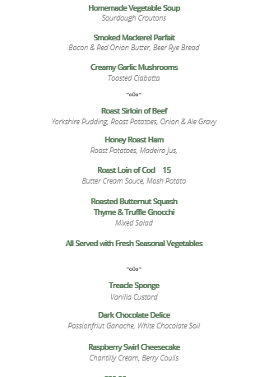

Friday 12th July 2024
