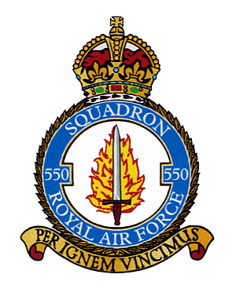

Membership Secretary - (to whom this form should be returned)
Steve Parker
Email: membership550@btinternet.com

Treasurer
Gary Berg
Email: garynb@hotmail.co.uk

Annual Subscription Form

Membership of the Association is £5.50 per annum, and the membership year runs from 1st July 2025 until 30th June 2026.

Number of Members |  | @ £5.50 per person

Name of members
being paid for:

Total Payment : | £

Please return the completed Annual Subscription Form to the Membership Secretary at the address shown at the top of this form.

Payments

Payments by bank transfer or standing order are preferred and the association's bank details are as follows:

Account Name : 550 Squadron Association

Sort Code : 30 - 93 - 72

Account Number : 01206018

Please reference any bank transfer payments with your name.

Cheques should be made out to “550 Squadron Association” and sent to the Treasurer at the address shown at the top of the form.

We also have the facility to accept payments via Paypal. Should you want to send payment this way please contact the Treasurer for more details.

To cut down on expenses, payments are not normally acknowledged unless there is an email address supplied.

